'Off The Cuff'
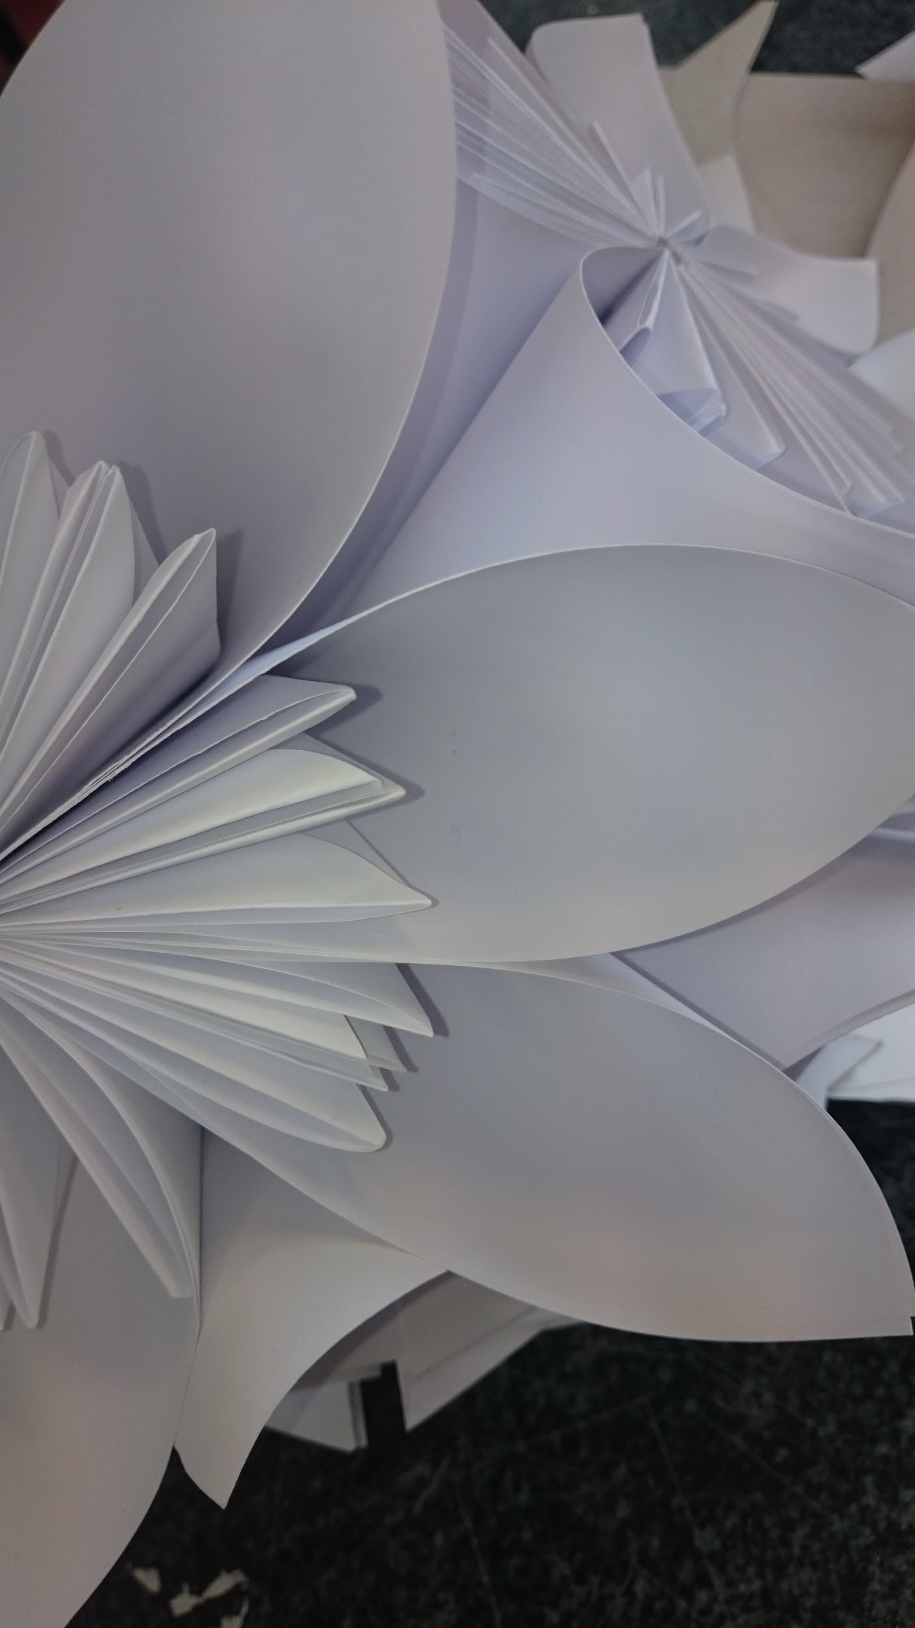
An exciting and varied showcase of work in response to the themes 'Poetry in Stitch & Flora, Fauna and Frippery' by the 1st & 2nd Year Textile Fibre Art Students From Ballyfermot College of Further Education

Date: 7th- 30th November
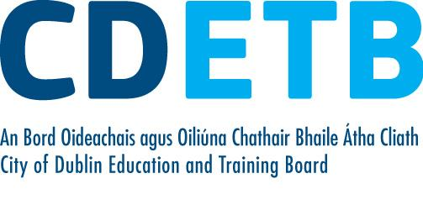
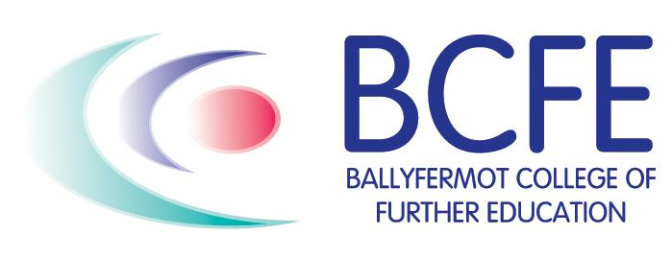
Venue: Ballyfermot Library

