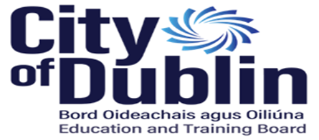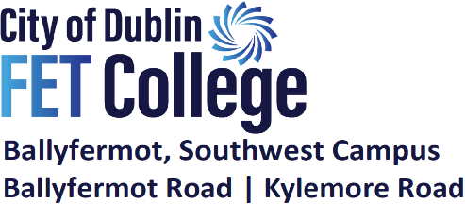
Annual Admission Notice 2026/2027
The following Annual Admission Notice has been prepared by the Board of Management of City of Dublin FET College Ballyfermot for the admission of students to the College for the academic year 2026/2027. This notice was published on the 5th November 2025.
A copy of City of Dublin FET College Ballyfermot’s Admission Policy is available: | To download at www.bcfe.ie  or by email at info@bcfe.cdetb.ie
Applications for admission to City of Dublin FET College Ballyfermot are only facilitated online from the 5th November 2025: | Option 1  Apply through www.bcfe.ie  where each applicant creates their individual MIT eNROL Account for this purpose  Option 2  Apply through www.cao.ie or www.fetchcourses.ie. City of Dublin FET College Ballyfermot will contact applicants to guide them through the process.
An application is considered fully complete once all fees are paid and registration forms are complete | Fees can be paid, and registration documents uploaded through www.bcfe.ie using the applicants MIT eNROL Account
All applications to City of Dublin FET College Ballyfermot will be accepted after the 5th November 2025 and the closing date for receipt of applications directly to Southwest Campus, Ballyfermot Road is the 25th of September 2026. Applications received after this date will be processed as late applications in accordance with the Admissions Policy of City of Dublin FET College Ballyfermot,

Please note that in line with the Colleges Policy and the Education (Admission to Schools) Act 2018, all waiting lists going forward are only in place for the academic year to which they apply. Therefore, if a student is seeking a place on a particular course and he or she is not successful in a given academic year, or is on a waiting list for that year, a new application must be made for the following year.

